# Lab 02

Instructor: Sidra Khatoon E-mail: skhatoon[@uit.edu](mailto:ad@uit.edu)

# Objective

The purpose of this lab session is install visual studio code. Also install Flutter extension is VS code. Create a first application of Hello World.

**Student Information**

|  |  |
| --- | --- |
| **Student Name** |  |
| **Student ID** |  |
| **Date** |  |

**Assessment**

|  |  |
| --- | --- |
| **Marks Obtained** |  |
| **Remarks** |  |
| **Signature** |  |

UIT University

Department of Engineering Technology

CET 222 Mobile Application Development

Lab 02

### Instructions

* Come to the lab on time. Students who are late more than 15 minutes, will not be allowed to attend the lab.
* Students have to perform the examples and exercises by themselves.
* Raise your hand if you face any difficulty in understanding and solving the examples or exercises.
* Lab work must be submitted on or before the submission date.
* Every lab Task is evaluated, so perform your lab task cautiously and get it checked timely.
* Mobile Phones are strictly prohibited in the lab.

### Objective

The purpose of this lab session is install visual studio code. Also install Flutter extension is VS code. Create a first application of Hello World.

1. Labs Descriptions

* **Installation of VS code:**

To install visual studio code run its setup file. Next move to the further steps for installation.

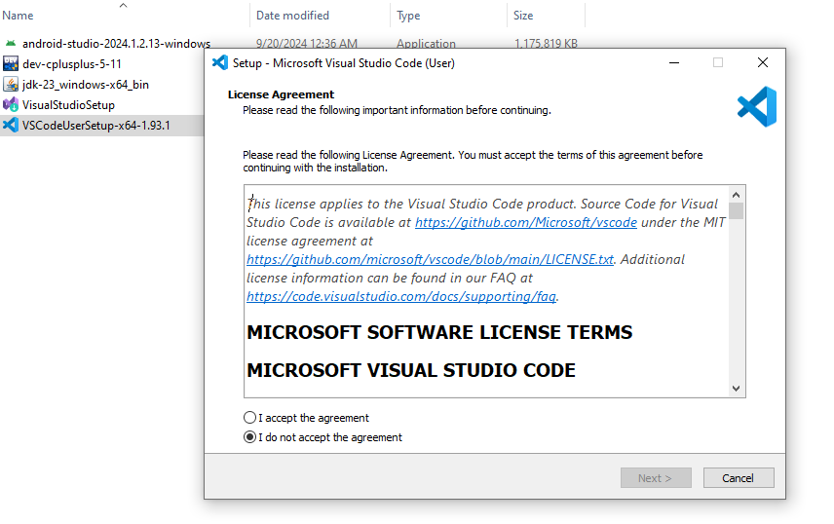

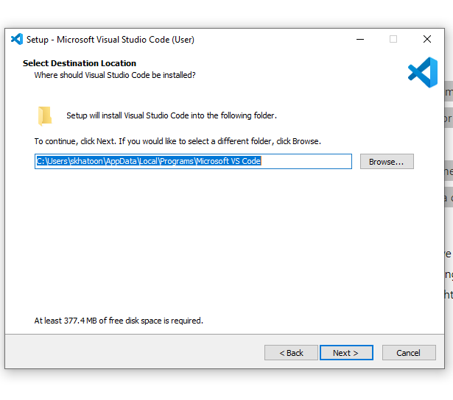

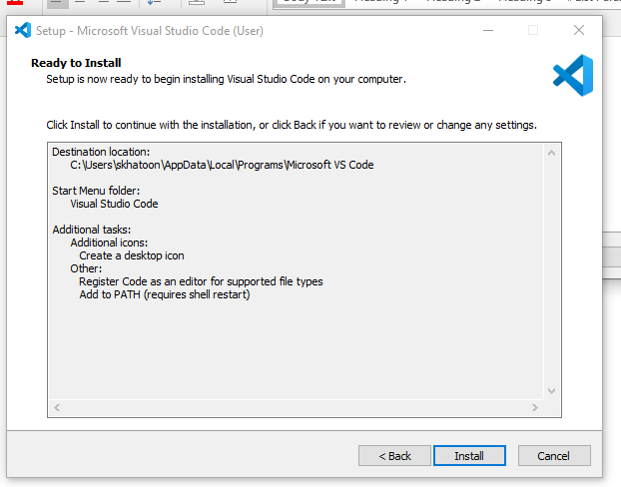

After VS code Installation process, we have download flutter extension files.

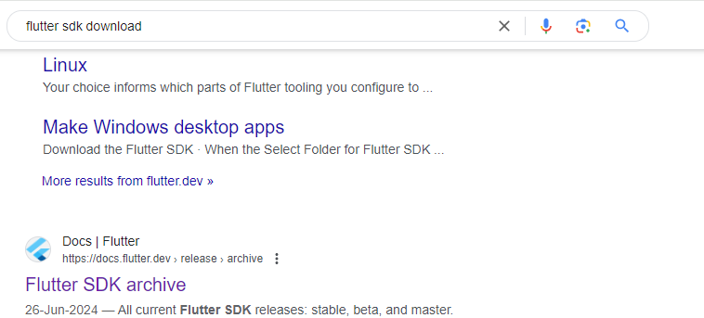

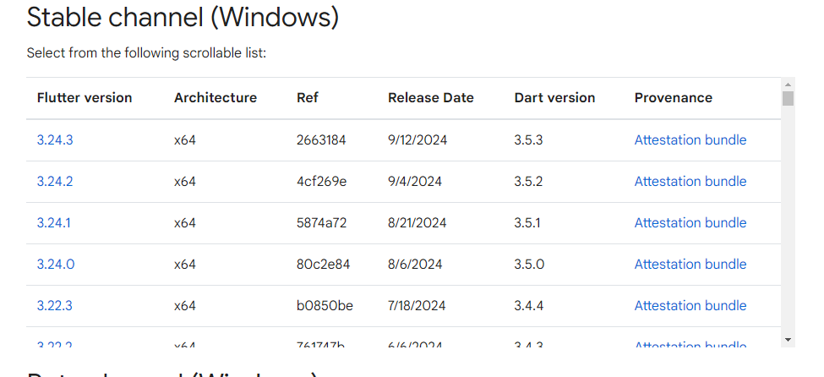

After downloading zip file unzip the folder and copy the folder in C Drive. Now open the folder and open bin folder and copy the path of bin folder. Now click on start search for environment. Open system environment variables.

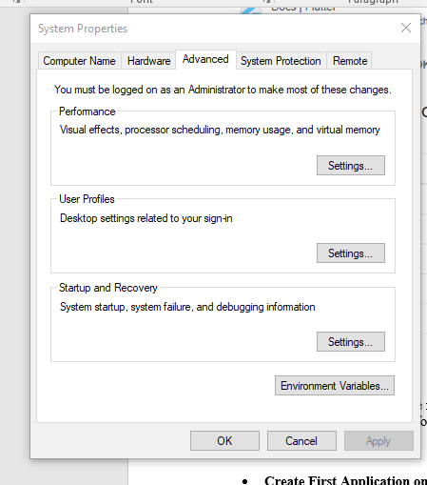

Now go to the environment variables setting.

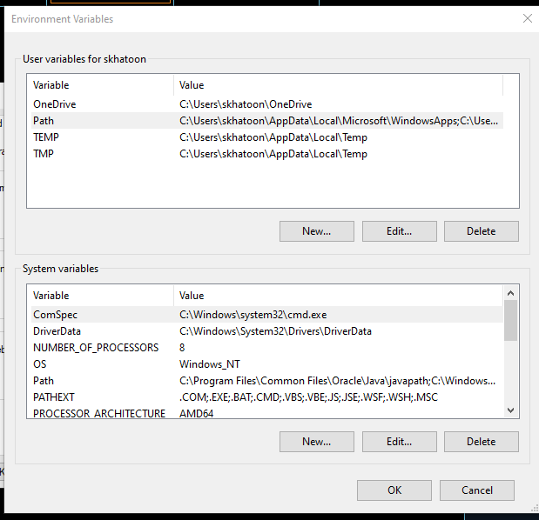

Now double click on path and add new path and paste be bin file path. Press ok.

After that open cmd and write flutter in command prompt.

Now install extension in VS code

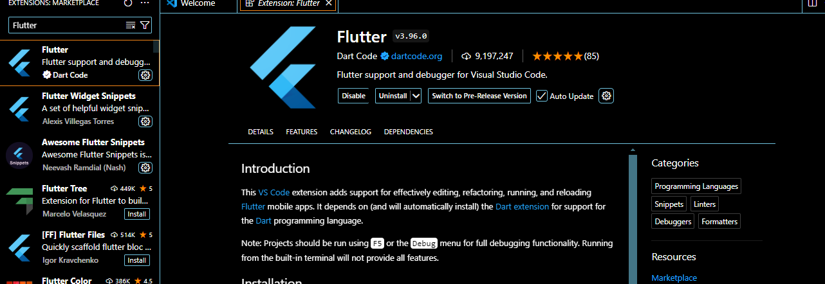

Now install dart extension.

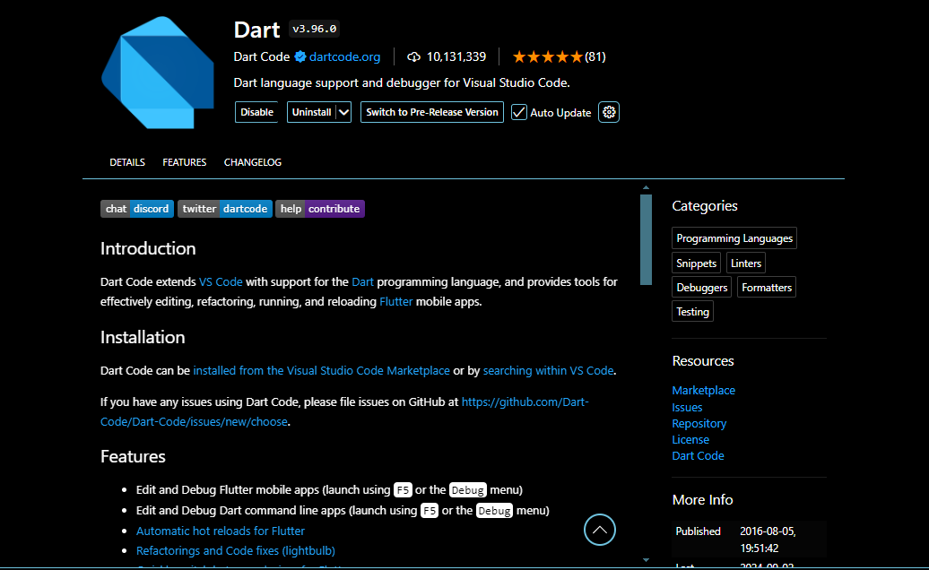

* **Create First Application on Flutter**

Go view option and open command palette and write flutter select new file option also what you want to create.

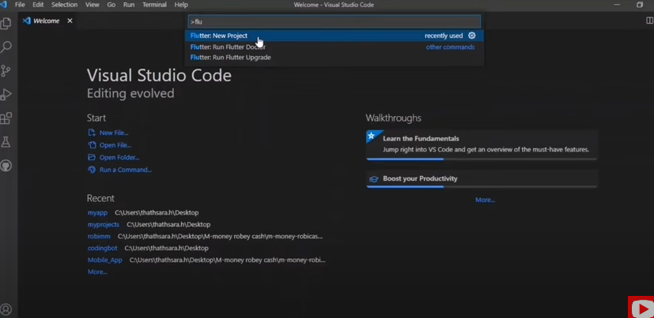

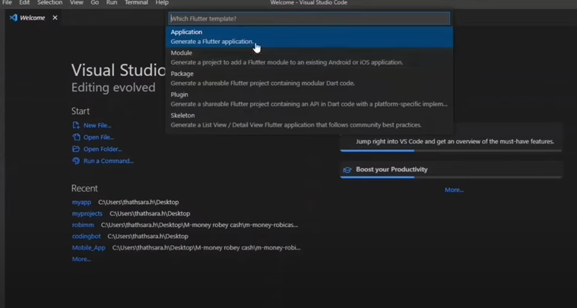

**Assessments:**

Q1: What is the role of the **Flutter extension in Visual Studio Code**, and how does it enhance the development experience for Flutter applications?

Q2: How does the debugging functionality of the Flutter extension in Visual Studio Code improve the efficiency of troubleshooting Flutter applications?

Q3: What are the benefits of the hot-reload feature provided by the Flutter extension in Visual Studio Code?

Q4: How does the Flutter extension in Visual Studio Code integrate with Dart, and why is this integration important for Flutter development?